ACSI Restaurant Report 2016
June 21, 2016

Fast Food Chains Improve Quality and Full-Service Restaurants Struggle to Stay Ahead

For the first time ever, Americans are spending more eating out than on groceries. Customer satisfaction with the Accommodation and Food Services sector is up 0.5% to 78.7 on the American Customer Satisfaction Index’s 100-point scale. The increase is due to a 2.6% improvement for limited-service (fast food) restaurants. Full-service restaurants drop 1.2% to 81, but remain one of the top four industries with the highest customer satisfaction.

Full-Service Restaurants
Smaller restaurant chains and independent restaurants, which make up the bulk of the industry, are behind the dip in customer satisfaction for sit-down dining this year. The combined ACSI score for these restaurants falls 2% to 81, but the industry overall remains very even. Over the past 10 years, customer satisfaction with full-service restaurants has never fallen below 80.

A year ago, smaller restaurants led the category alongside Texas Roadhouse, but it is a restaurant-retail hybrid that shoots to the top for 2016. Cracker Barrel gains 4% to take first place with an ACSI score of 83. The company—which is part restaurant and part Americana gift shop—reported a sales increase and more revenue per customer during the first part of the year.

Texas Roadhouse slips 1% to tie LongHorn Steakhouse (up 1%) at 82, while most of the other large chains improve. Olive Garden, part of the Darden group along with LongHorn, climbs 3% to 81, followed closely by Red Robin, up 4% to 80.

Red Lobster gains 3% and ties with Applebee’s, which edges up 1% to 79. Ruby Tuesday improves the most, jumping 7% from last place to an ACSI score of 78, which suggests that its brand transformation initiatives—from new menu items to remodeled restaurants—are beginning to work.

TGI Fridays also comes in at 78, a 3% rise from a year ago. Outback Steakhouse is one of the few large chains to move in the opposite direction, slipping 1% to 77. Chili’s Grill & Bar inches up 1% to 75 and Denny’s dips the same amount to 74, landing at the bottom of the category.

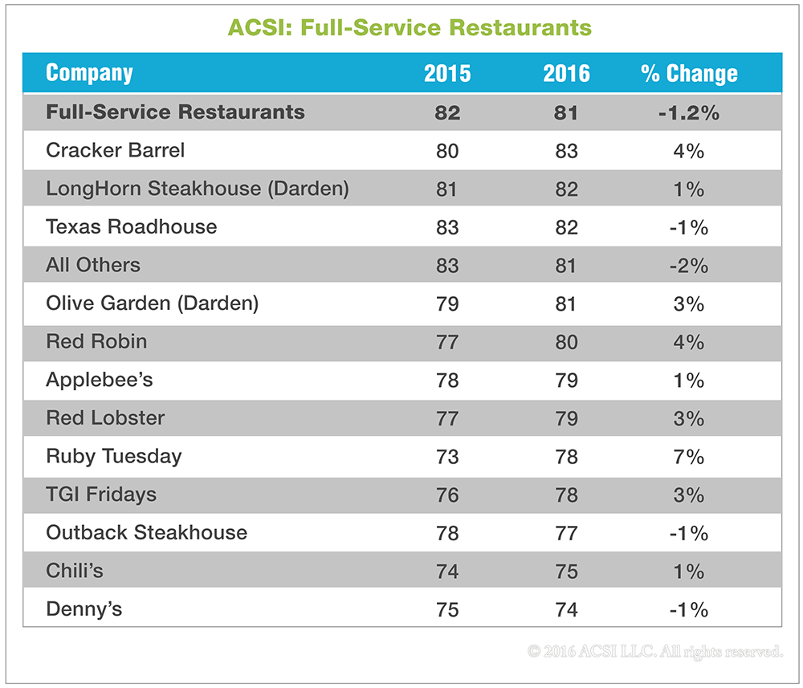

According to diners, full-service restaurants do a great job in getting orders right (89) and restaurants are clean and well laid out (86). However, many elements of the dining experience rate slightly below what they were a year ago, including food quality (86), waitstaff courtesy and helpfulness (85), and variety of beverage options (82). According to patrons, service speed (82), along with beverage variety, are low points for the industry. On the other hand, food menu variety has improved (86). Likewise, full-service restaurant websites are better, with a user satisfaction rating of 83.

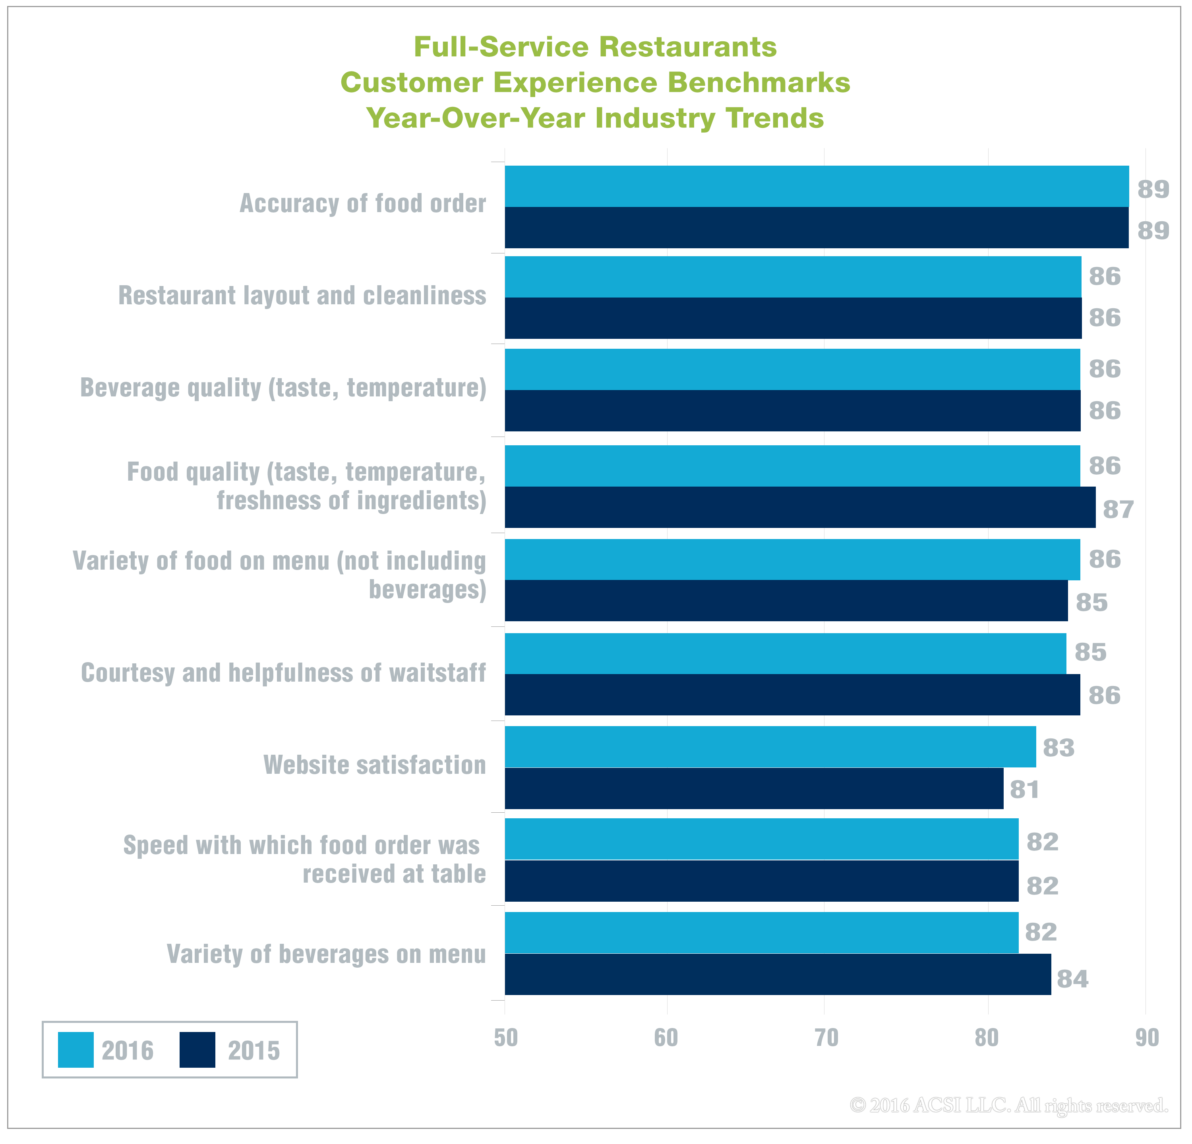

Limited-Service Restaurants
Customer satisfaction with fast food restaurants is up 2.6% to an ACSI score of 79. Price has always been a strong point for fast food, but a new focus on quality ingredients is helping to boost quick-service restaurants to levels approaching sit-down restaurants.

Chicken specialist Chick-fil-A leads the category, gaining 1% to an ACSI score of 87. According to its customers, Chick-fil-A surpasses other fast food restaurants by a wide margin. Papa John’s comes in a distant second at 82 even though its score is up 5% from a year ago. Among pizza makers, Papa John’s remains the most satisfying chain. Little Caesars, however, shows the biggest improvement in the entire fast food category, jumping 9% to 81 and landing just a notch below Papa John’s.

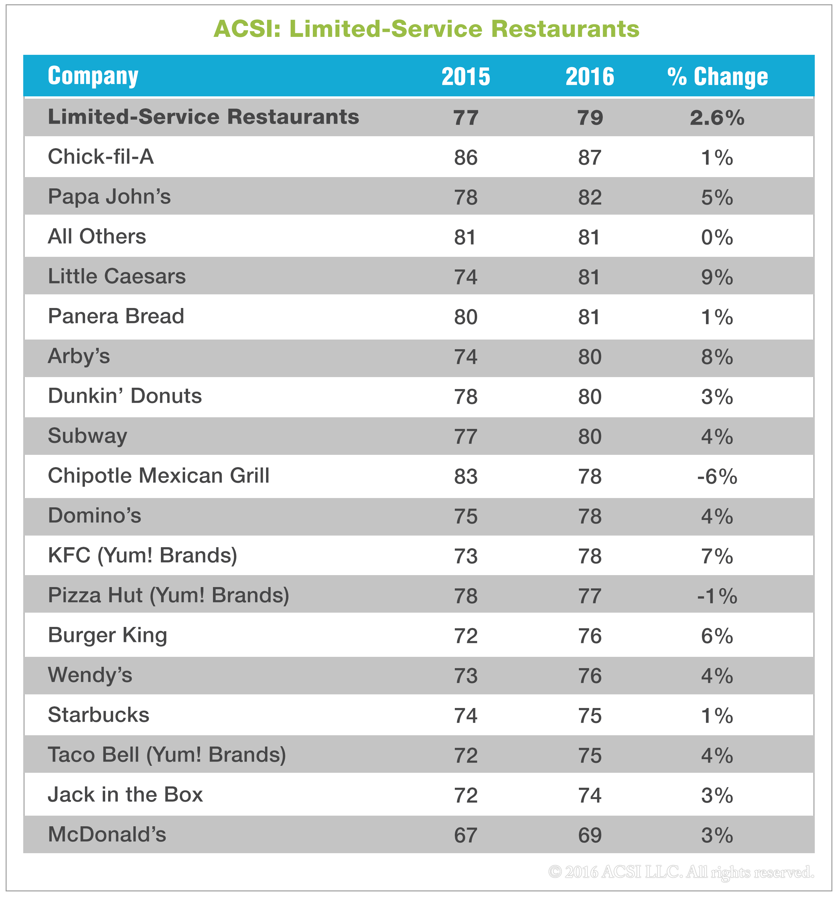

Panera Bread inches up 1% to 81, tied with the combined score of smaller fast food chains. Arby’s advances 8% to 80 following a major overhaul of its menu and store layout. Last year, the company opened 60 new U.S. locations and remodeled 100 of its existing stores. Subway and Dunkin’ Donuts gain 4% and 3%, respectively, to tie with Arby’s at 80. Starbucks, which has scored below the industry average since 2014, inches up 1% to 75.

Chipotle Mexican Grill takes the biggest ACSI hit, falling 6% to 78 in the wake of food-borne illness outbreaks at some of its stores. As of the first quarter of 2016, sales were down more than 20% year-over-year. As of June, Chipotle's stock price was down over 45% compared to levels seen prior to the outbreak. Quality issues can be challenging, particularly for food service companies, which could elongate Chipotle's recovery time.

Two other chains tie with Chipotle at 78: Domino’s (+4%) and KFC (+7%). Despite its large gain, Yum! Brands’ KFC remains well behind direct competitor Chick-fil-A. Likewise, Taco Bell—the Mexican food offering from Yum! Brands—improves 4% to 75, but still trails Chipotle. The third Yum! chain, Pizza Hut, is the lowest-scoring pizza maker this year (down 1% to 77).

Hamburger chains come in below the industry average, but all show improvement. Burger King jumps 6% to tie Wendy’s (+4%) at 76, and Jack in the Box gets a 3% boost to 74. While McDonald’s remains in last place at 69, the fast food giant gains 3% from a year ago primarily on the strength of its new all-day breakfast menu.

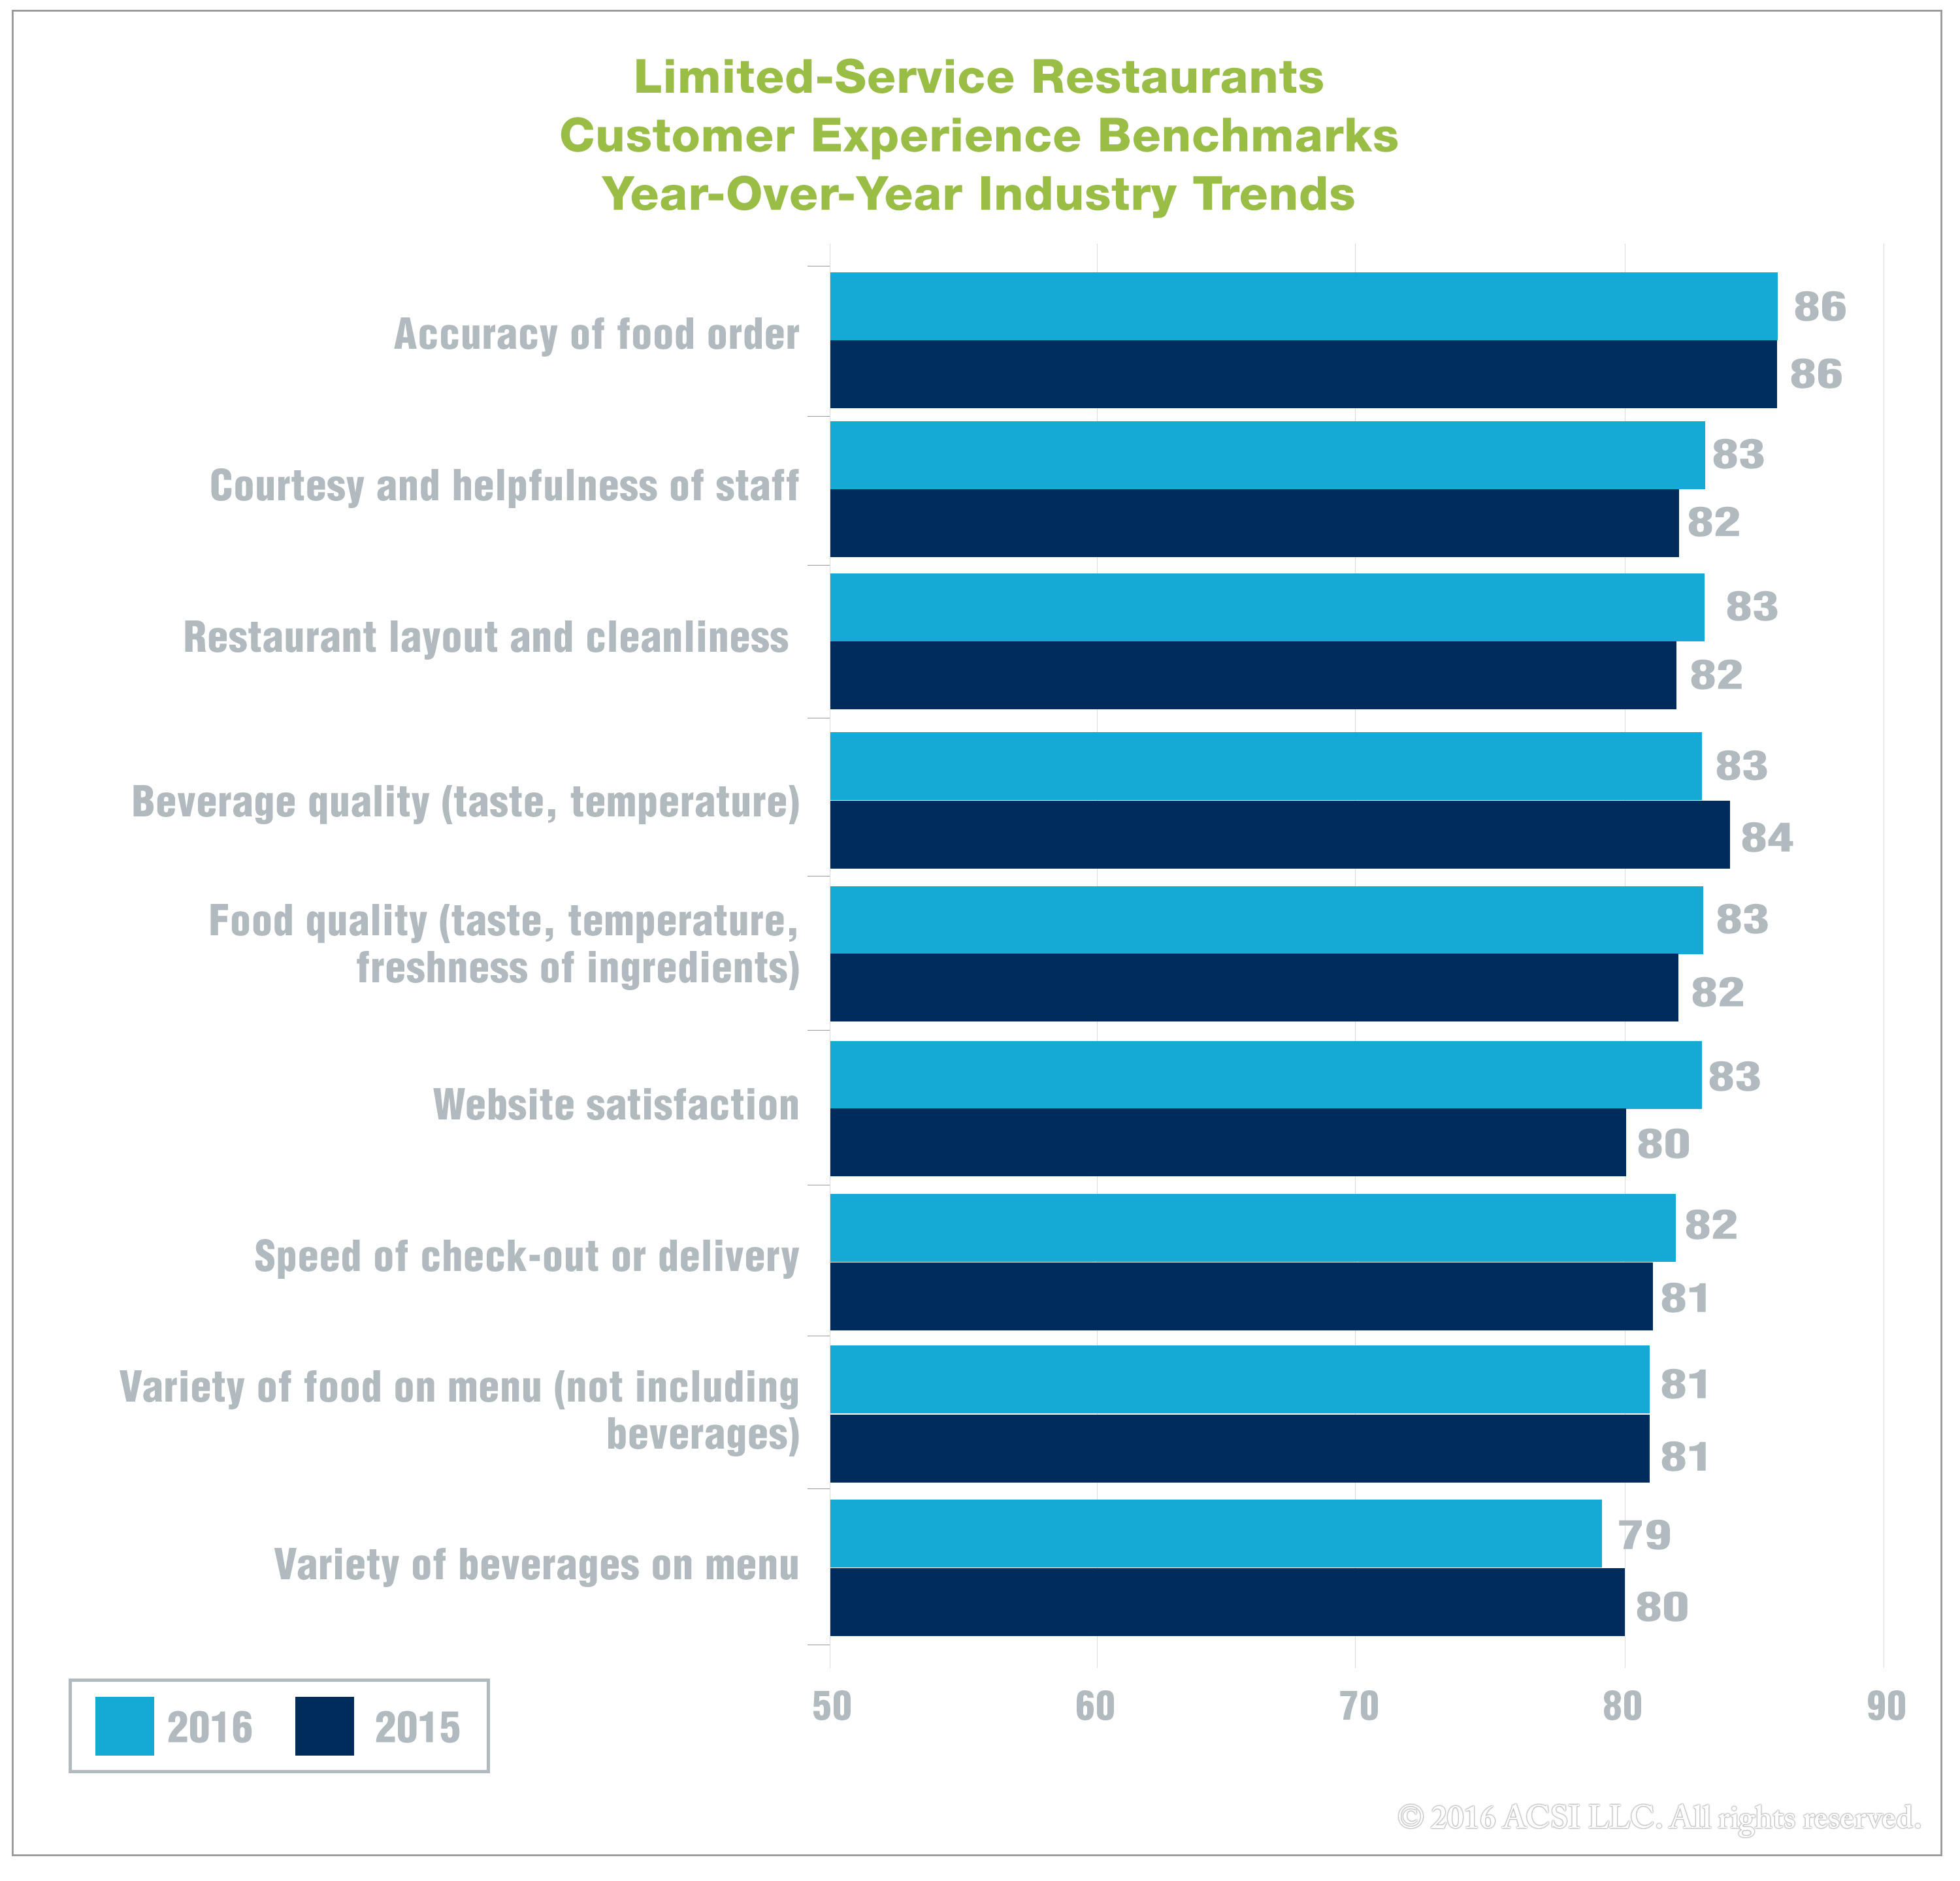

Fast food restaurants receive fairly high marks for the overall dining experience, but remain well below full-service restaurants. According to customers, food orders are accurate (86) and the quality of food (83) has improved from a year ago. Fast food chains provide courteous staff (83) and layout and cleanliness have improved (83). Fast food websites (83) are above average compared to the ACSI score for all websites (80.0). Speed of checkout or delivery—a hallmark of the fast food experience—gets good marks from diners and shows slight improvement over a year ago (82).

Consumers are the least satisfied with food and beverage variety. Drink options rate lowest at 79 and companies might gain traction with customers by expanding choices to meet changing consumer palettes, especially as sweetened soft drinks continue to fall out of favor.

No advertising or other promotional use can be made of the data and information in this report without the express prior written consent of ACSI LLC.

About This Report
The ACSI Restaurant Report 2016 on full-service and limited-service (fast food) dining chains is based on interviews with 4,786 customers, chosen at random and contacted via email between March 5 and March 31, 2016. Customers are asked to evaluate their recent experiences with the largest sit-down and fast food restaurants in terms of market share, plus an aggregate category consisting of “all other”—and thus smaller—restaurants in those industries.

The survey data are used as inputs to ACSI’s cause-and-effect econometric model, which estimates customer satisfaction as the result of the survey-measured inputs of customer expectations, perceptions of quality, and perceptions of value. The ACSI model, in turn, links customer satisfaction with the survey-measured outcomes of customer complaints and customer loyalty. ACSI clients receive confidential industry-competitive and best-in-class data on all modeled variables and customer experience benchmarks.

